**SNAPSHOTS OF THE OUTPUTS**

* **Main Menu -**

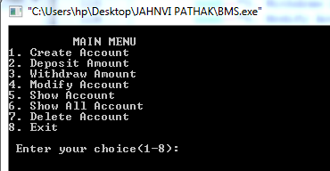

* **Create Account -**

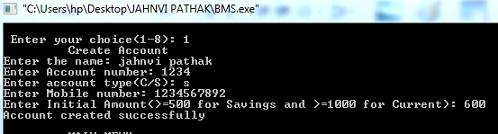

* **Deposit Amount -**

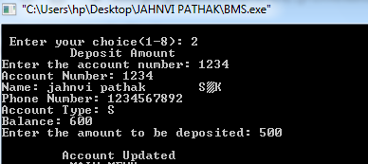

* **Withdraw amount -**

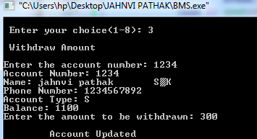

* **Modify -**

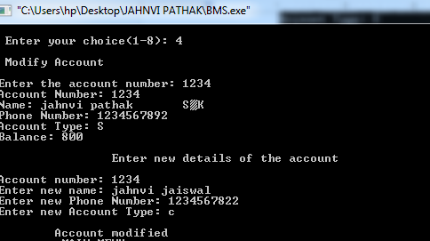

* **Show Account Details -**

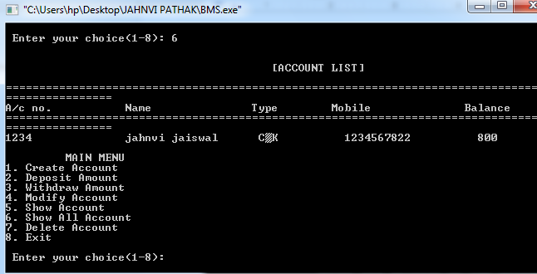

* **Delete Account -**

